

**Faculty of engineering - Shoubra**

**Benha University**

**Research Article / Research Project / Literature Review**

In fulfillment of the requirements of

|  |  |
| --- | --- |
| **Department** | Engineering Mathematics and Physics |
| **Division** | ---------- |
| **Academic Year** | 2019-2020 Preparatory |
| **Course name** | Computer |
| **Course code** | **ECE001** |

**Title:-**

**Build a website on recent computer engineering topics**

**By:**

|  |  |  |  |
| --- | --- | --- | --- |
|  | Name | Edu mail | B.N |
| 1 | Mustafa Mahmoud Mohamed Shoman | mustafa196043@feng.bu.edu.eg | 937 |

**Approved by:**

|  |  |  |
| --- | --- | --- |
| Examiners committee | | Signature |
| 1 | Dr.Ahmed Bayoumi |  |
| 2 | Dr.Shady Elmashad |  |
| 3 | Dr. Abdelhamid Attaby |  |
|  | | |

**Topic:** Artificial Intelligence

**Application brief:**

I chose the topic of ***artificial intelligence*** because it is the future. Artificial intelligence's ultimate research aim is to develop technology that enables computers and machines to work smart. Artificial Intelligence increases the speed, accuracy and productivity of human efforts. AI techniques can be used at financial institutions to classify which transactions are likely to be fraudulent, implement quick and reliable credit rating, and automate severe data management activities manually. Artificial Intelligence (AI) helps computers to learn from experience, adapt to new stimuli, and perform tasks of a human nature. Most AI examples you hear of today – from chess-playing machines to self-driving cars – rely heavily on deep learning and the processing of natural languages. Using these technologies, computers can be equipped to perform different tasks by handling large quantities of data and recognizing patterns in the data. The technology can be applied to a great many different industries and sectors. Across the healthcare sector, AI is being studied and used in patients for dosing medications and various therapies, and in the operating room for surgical procedures. Artificial intelligence also has applications in the financial industry, where it is used to detect and flag activity in banking and finance such as unusual debit card usage and large account deposits—all of which help a bank's fraud department. Applications for AI are also being used to help streamline and make trading easier. This is done by making supply, demand, and pricing of securities easier to estimate. High artificial intelligence systems are systems that carry out the activities that are known as human. Such structures tend to be more complicated and complex. We are trained to manage situations where we might need to solve problems without the involvement of a human. Such systems can be found in applications such as self-driving cars or in operating rooms in hospitals. In the long term, an significant question is what will happen if the search for powerful AI succeeds and an AI system

at all cognitive tasks get better than humans. As shown by the I.J. Effective developing smarter AI systems in 1965 is a cognitive task in itself. Such a device would theoretically experience recursive self-improvement, causing an explosion of knowledge that would leave the human intellect far behind. Such a super intelligence will help us eliminate war, disease, and poverty by inventing innovative new technology, and so the development of powerful AI could be the greatest event in human history. However, some experts have expressed concern that this may also be the last, unless we learn to align the AI's goals with ours before it becomes super intelligent. Artificial Intelligence (AI) is the ability to think and learn through a computer program or machine. It is also a field of study that attempts to make "smart" computers work alone without the encoding of commands*. In 1955 John McCarthy developed the name "Artificial Inteligencence".*

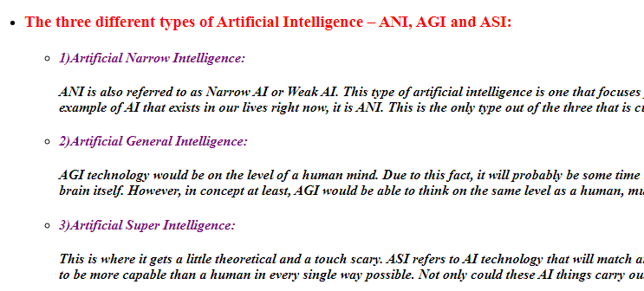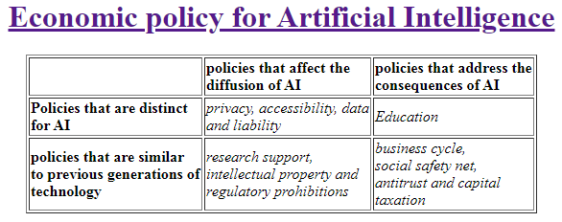**Screenshots:**

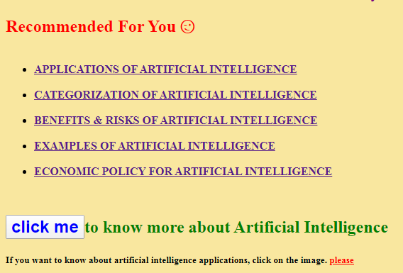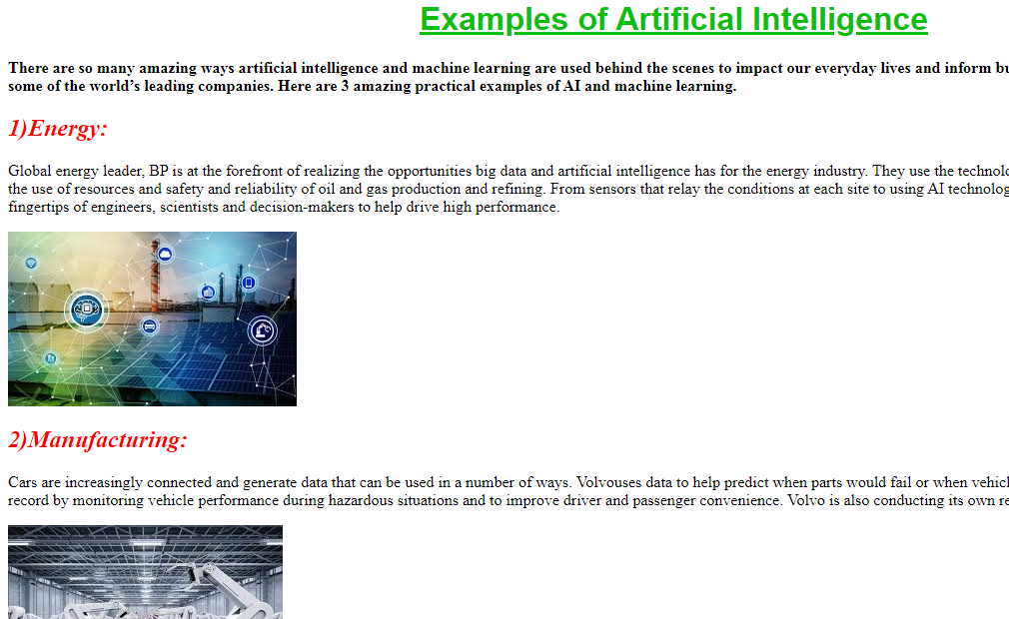

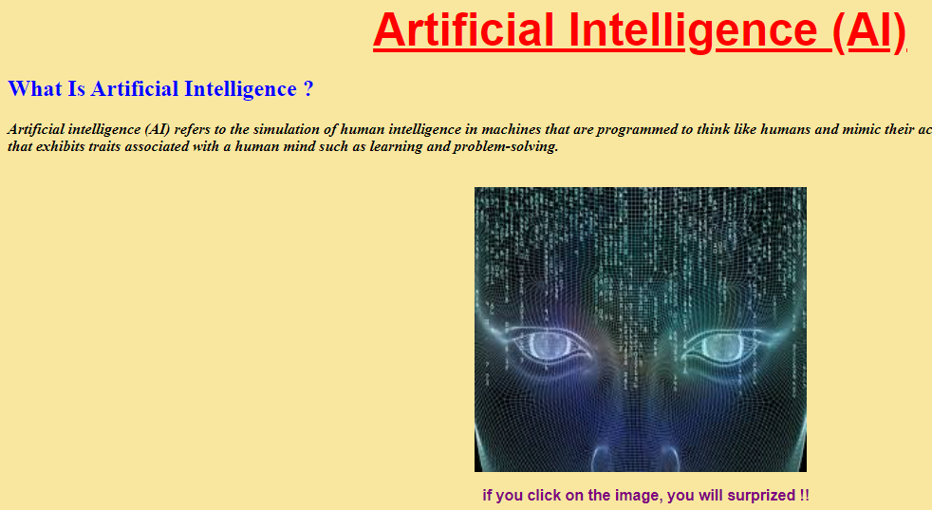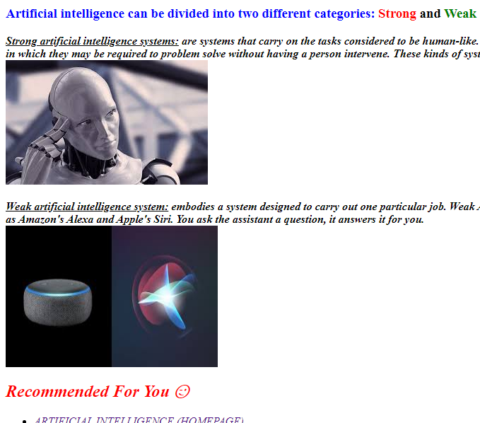

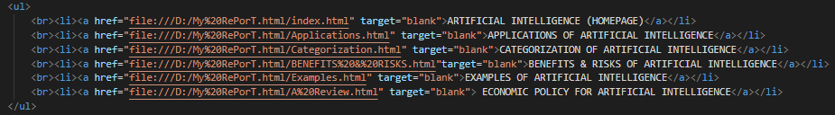**Source code:**

